# React

# ReactJS-HOL

# Mandatory HandsOn

Create a React App named “bloggerapp” in with 3 components.

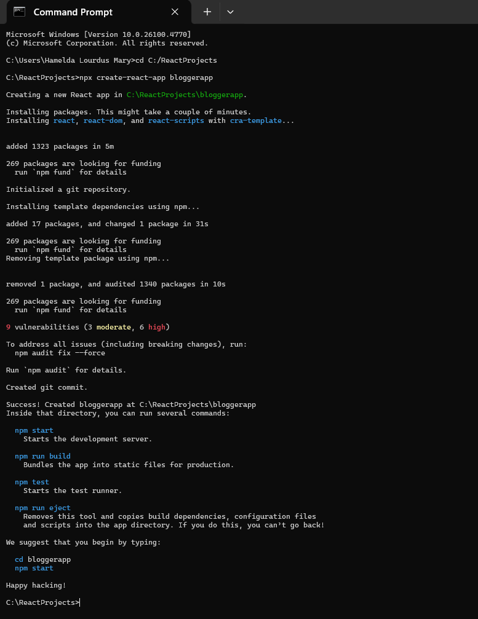

**Create a components:**

1. **BookDetails.js**

import { books } from '../data/books';

const showBooks = true; // Toggle for conditional rendering

const bookdet = showBooks ? (

    <ul>

        {books.map((book) => (

            <div key={book.id}>

                <h3>{book.bname}</h3>

                <h4>{book.price}</h4>

            </div>

        ))}

    </ul>

) : (

    <p>Book details are hidden.</p>

);

export { bookdet };

1. **BlogDetails.js**

const showInstall = true; // Toggle for conditional rendering

const content = (

    <div>

        <h1>React Learning</h1>

        <p><strong>Stephen Biz</strong></p>

        <p>Welcome to learning React!</p>

        <h1>Installation</h1>

        {showInstall ? (

            <p><strong>Schwadzenier</strong></p>

        ) : (

            <p>Installation instructions coming soon.</p>

        )}

        <p>You can install React from npm.</p>

    </div>

);

export { content };

1. **CourseDetails.js**

const showCourses = true; // Toggle for conditional rendering

const courseList = [

    { name: 'Angular', date: '4/5/2021' },

    { name: 'React', date: '6/3/2021' },

];

const coursedet = showCourses ? (

    <div>

        {courseList.map((course, index) => (

            <div key={index}>

                <h1>{course.name}</h1>

                <p>{course.date}</p>

            </div>

        ))}

    </div>

) : (

    <p>Course details not available.</p>

);

export { coursedet };

**books.js**

// src/data/books.js

export const books = [

    { id: 101, bname: 'Master React', price: 670 },

    { id: 102, bname: 'Deep Dive into Angular 11', price: 800 },

    { id: 103, bname: 'Mongo Essentials', price: 450 },

];

**App.js**

import './App.css';

import { content } from './components/BlogDetails';

import { bookdet } from './components/BookDetails';

import { coursedet } from './components/CourseDetails';

function App() {

  return (

    <div className="main-container">

      <div className="mystyle1">

        <h1>Course Details</h1>

        {coursedet}

      </div>

      <div className="st2">

        <h1>Book Details</h1>

        {bookdet}

      </div>

      <div className="v1">

        <h1>Blog Details</h1>

        {content}

      </div>

    </div>

  );

}

export default App;

**App.css**

.st2 {

  border-left: 4px solid green;

  padding-left: 20px;

  float: left;

  margin-left: -250px;

  width: 30%;

}

.v1 {

  border-left: 4px solid green;

  padding-left: 40px;

  float: left;

  margin-left: -250px;

  width: 30%;

}

.mystyle1 {

  padding-left: 10px;

  float: left;

  width: 30%;

  margin: 0;

}

.main-container {

margin-top: 50px;

margin-left: 150px;

}

.main-container::after {

  content: "";

  display: table;

  clear: both;

  margin: 0;

}

**Output:**

npm start

